**Output Screenshots**

1. Home Page

1. Admin Login Page

When We click on Sign In in Home Page we will be navigating to the Sign In Page.

1. When Admin Clicks on Sign In Button he/she will be navigated to Admin Form. (by default men’s shoes is displayed)

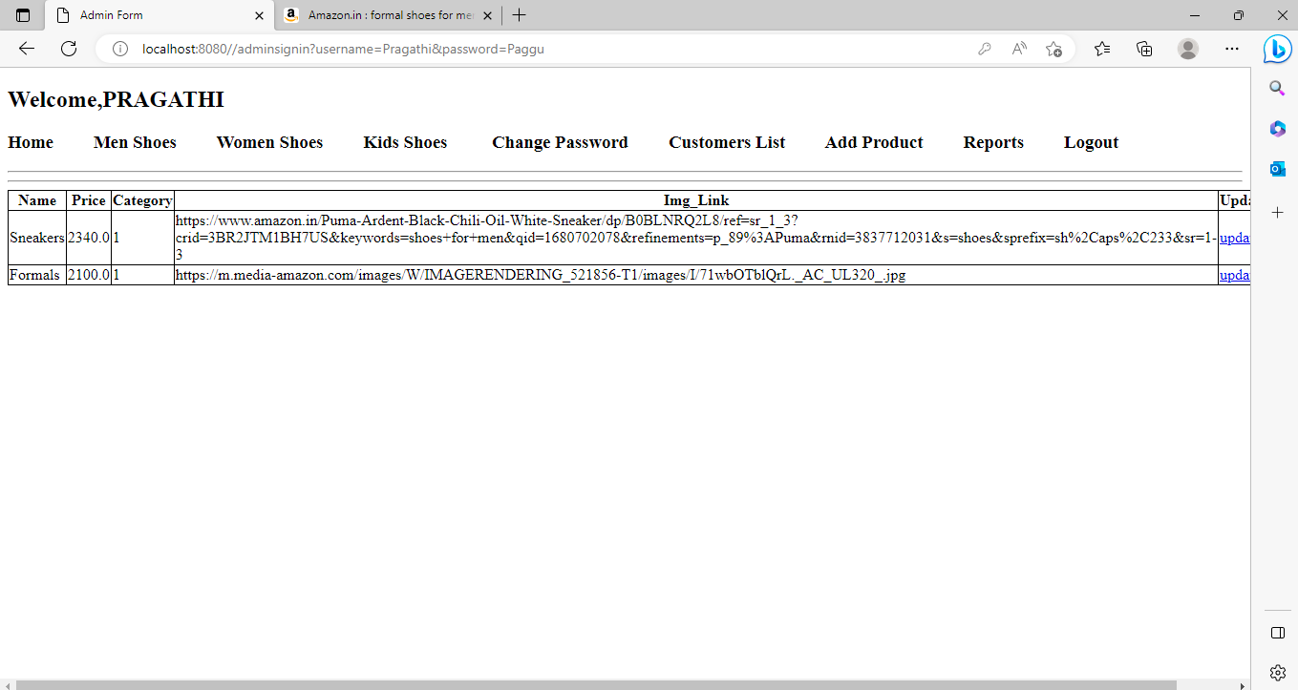

1. Women’s Shoe Clicked

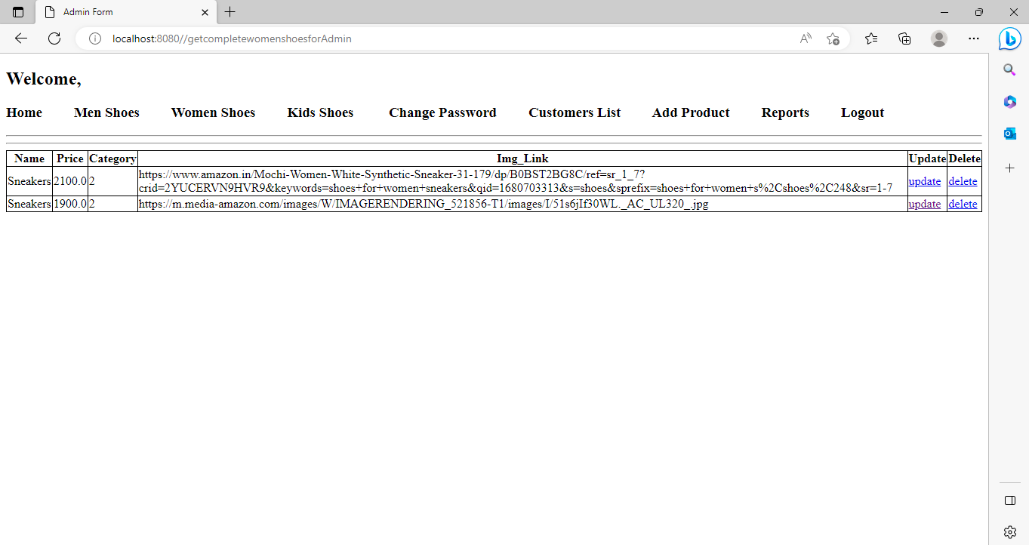

1. Kid’s Shoes clicked

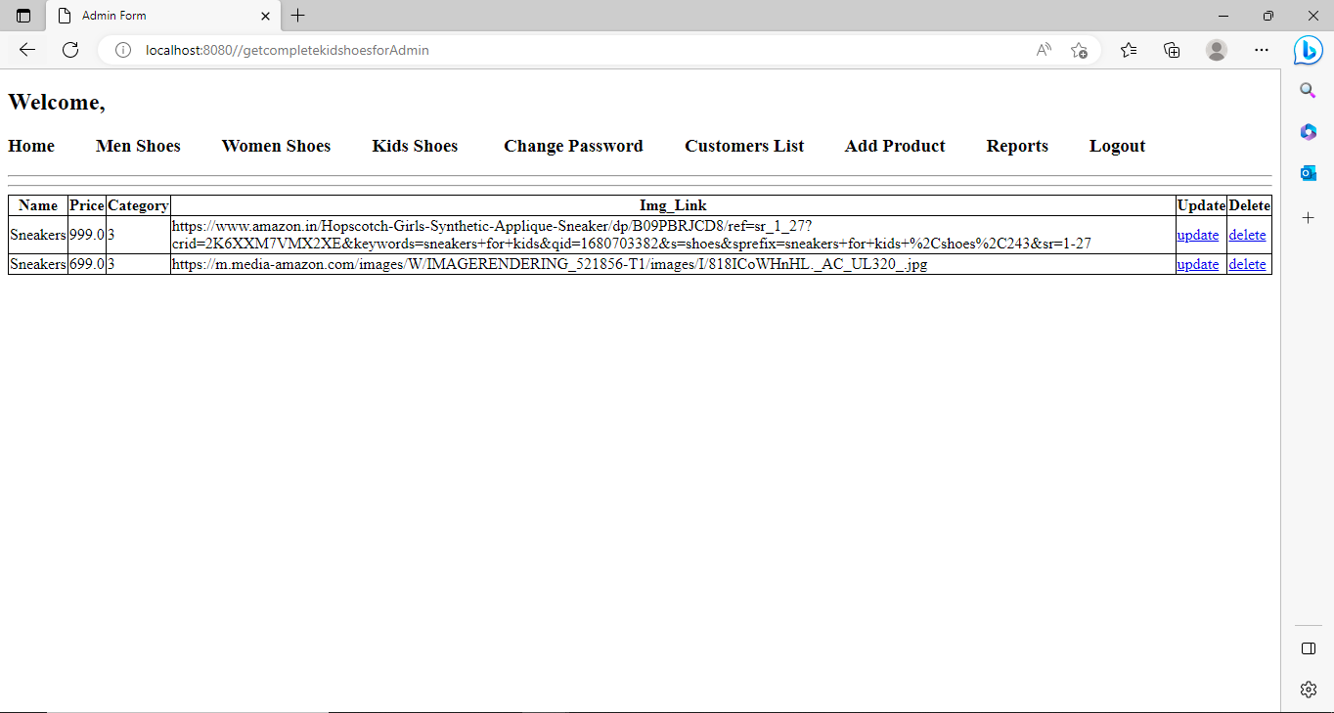

1. Customer List Clicked

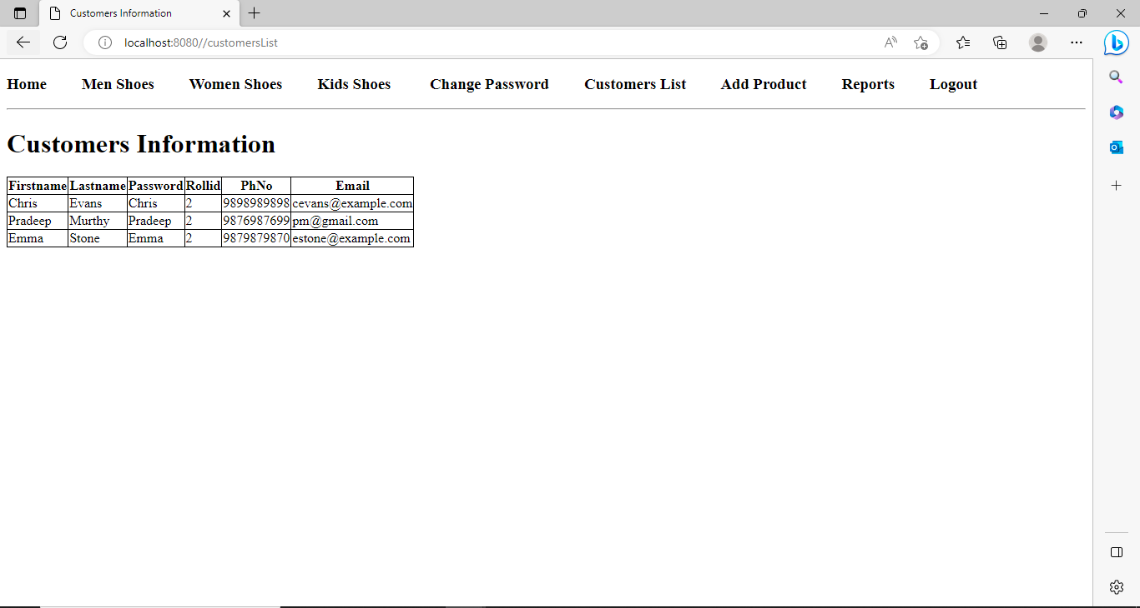

1. Add Product Cliked

After clicking add product button the new product is added and displayed

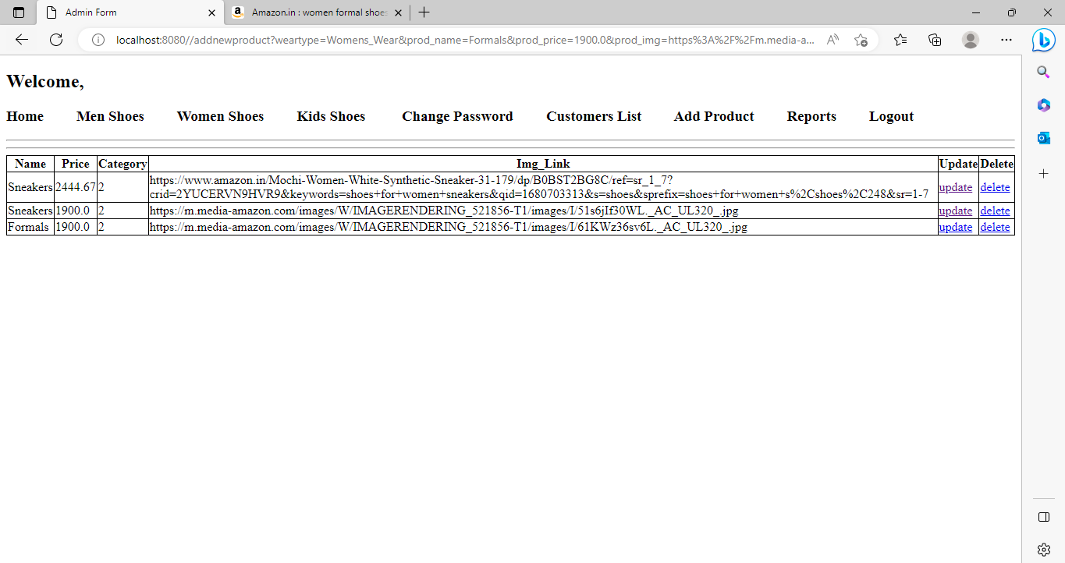

1. Reports Clicked

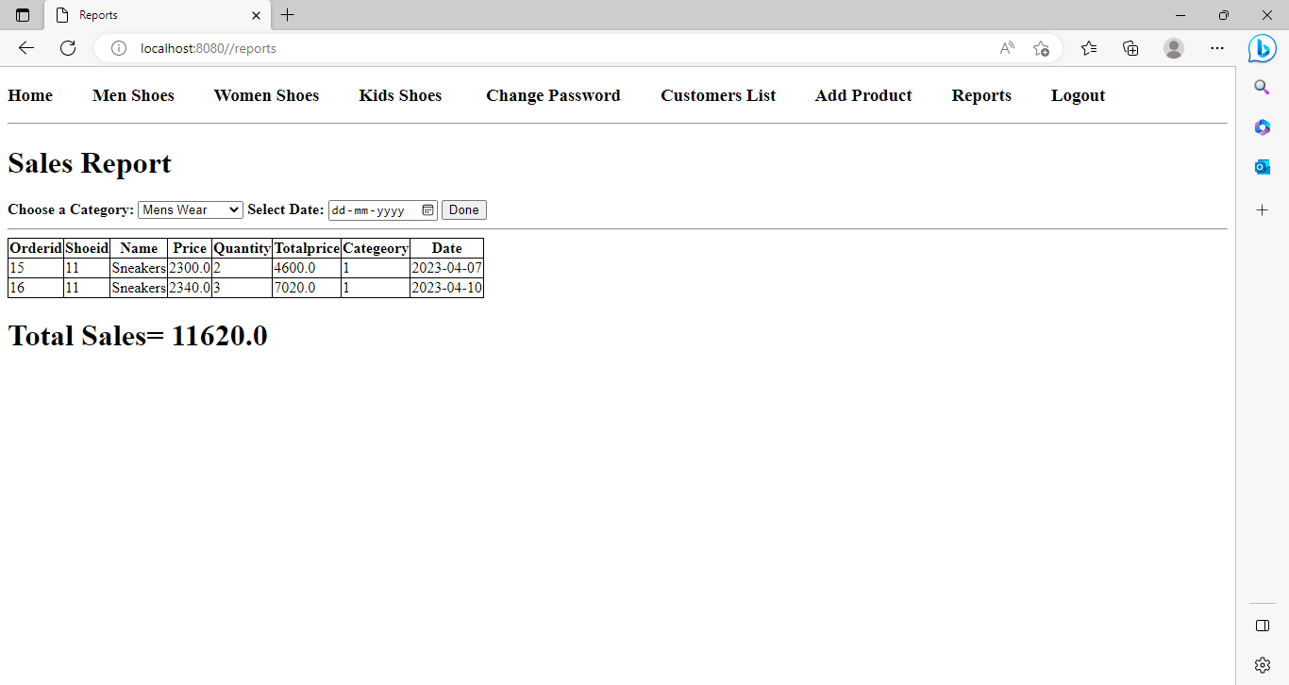

1. Change Password clicked (after clicking change password, admin needs to relogin)

1. Logout navigates back to Sign In Page.

1. Customer Sign Up and Login

After clicking SignUp User is redirected to login page and user needs to login:

1. After logging in user is redirected to Home Page where the user can select the category of his/her choice and they will be directed to the respective category List of Products.

* Men’s Shoes Clicked

* First Product Clicked

* User Selects the Quantity and clicks on Place Order and user is redirected to cart and selected items are displayed

* After Clicking Book Order user is directed to payment confirmation Page

* user can navigate back to home page by clicking on back to home.

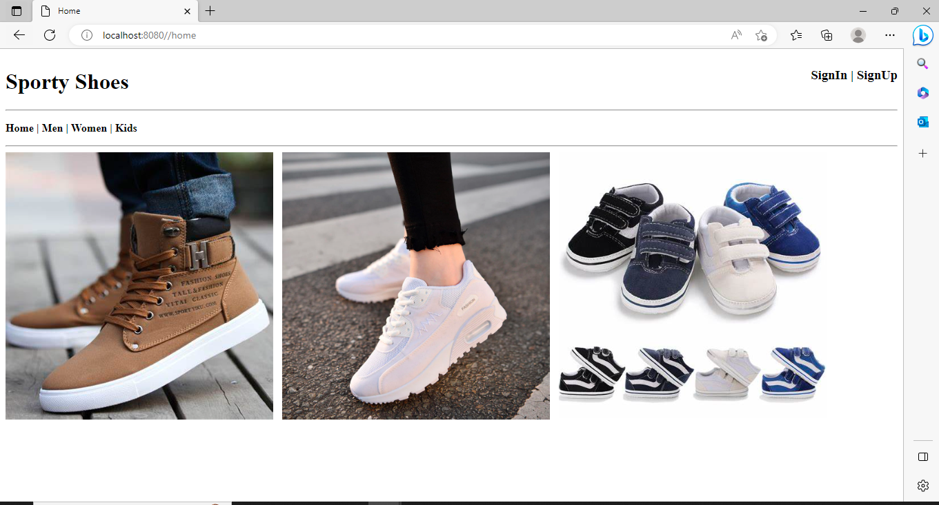

* Women’s Shoes Clicked

* Second Product Clicked

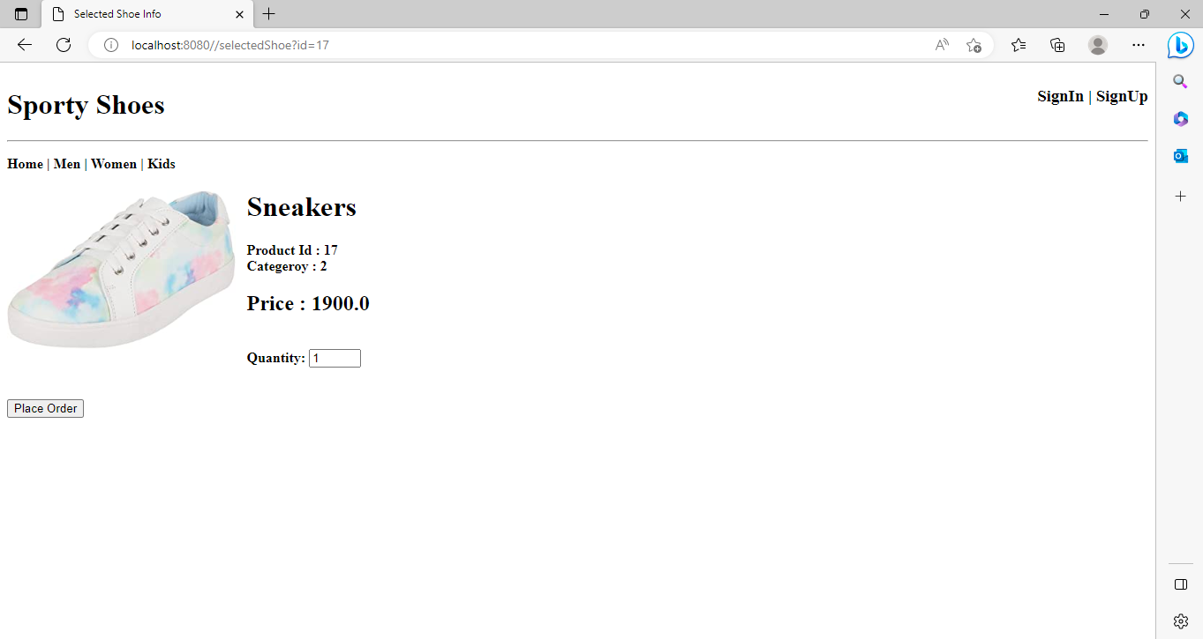

* User Selects the Quantity and clicks on Place Order and user is redirected to cart and selected items are displayed

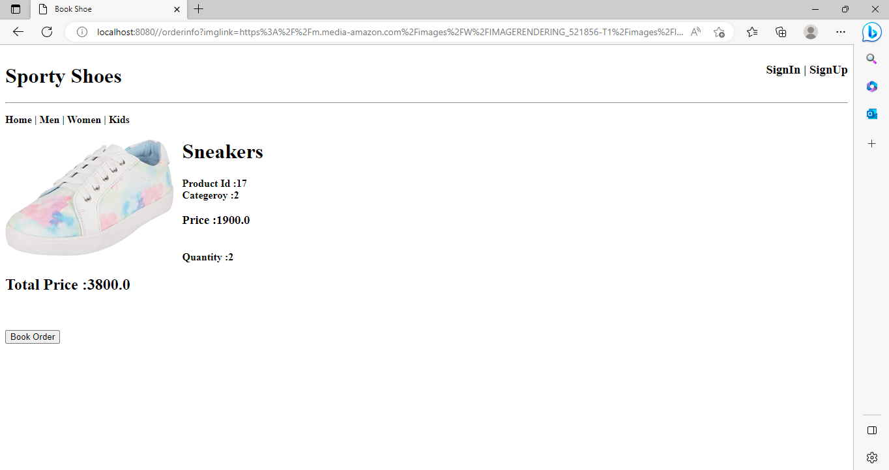

* After Clicking Book Order user is directed to payment confirmation Page

* user can navigate back to home page by clicking on back to home.



* Kids Shoes Clicked

* Second Product Clicked

* User Selects the Quantity and clicks on Place Order and user is redirected to cart and selected items are displayed

* After Clicking Book Order user is directed to payment confirmation Page

* user can navigate back to home page by clicking on back to home.



1. Admin Cllicks on Update in any Product category then admin can update the product details

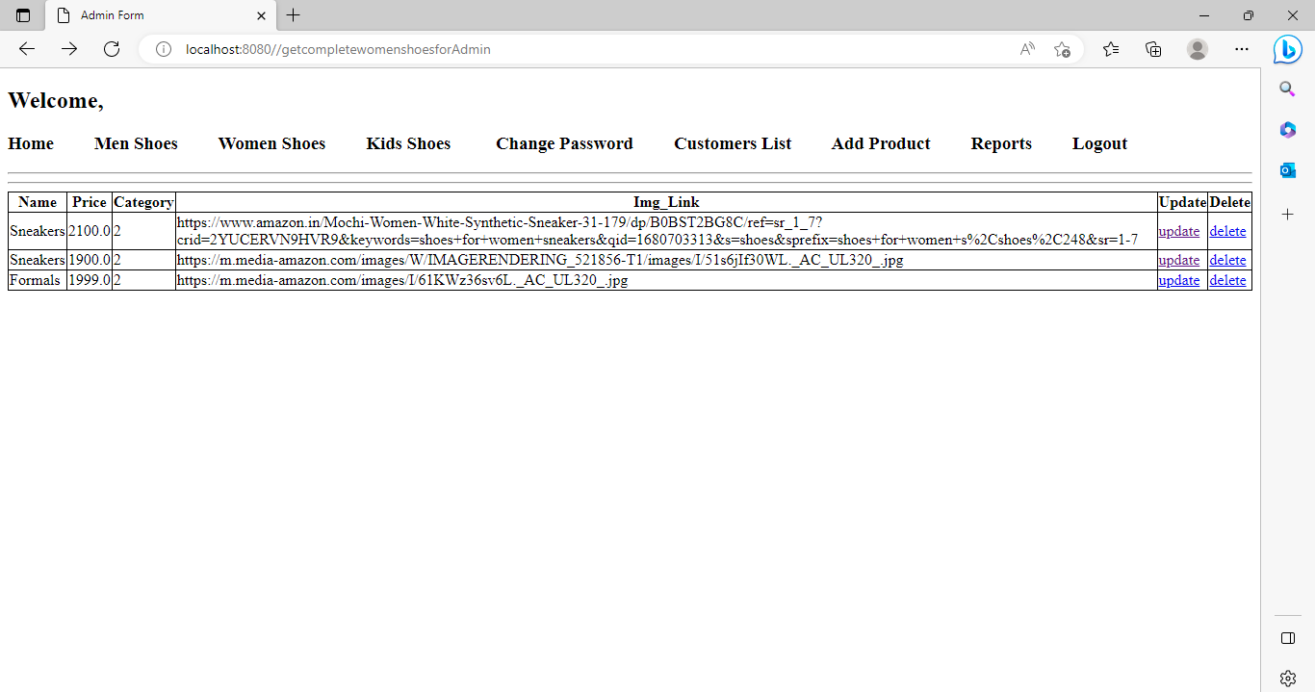

Clicks on update

Product Price is updated from 2100.0 to 2444.67

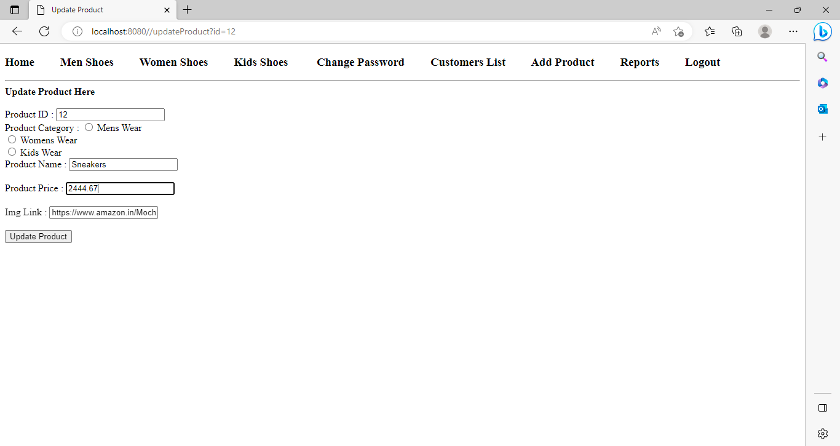

Updated Price displayed after clicking on update product

1. Admin clicks on delete product to delete a product from any category of his/her choice

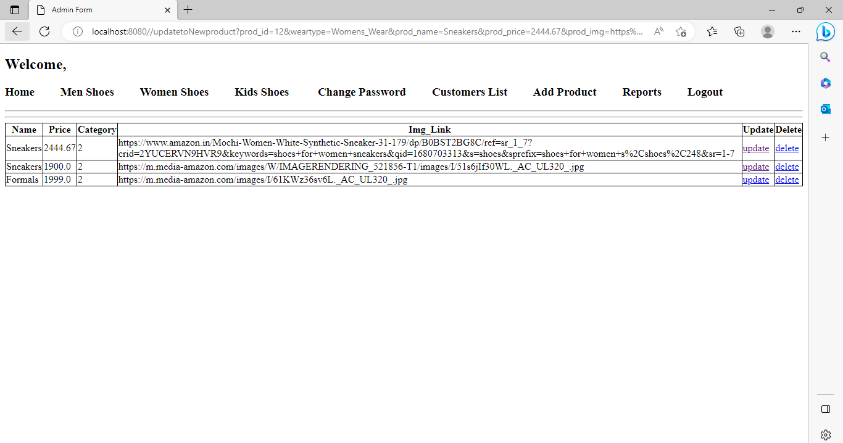

After clicking on delete of third product displayed, the third product is deleted

